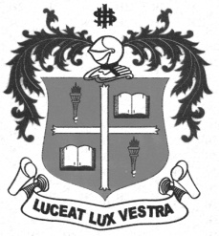
LOYOLA COLLEGE (AUTONOMOUS), CHENNAI – 600 034
B.A. DEGREE EXAMINATION – HISTORY
FOURTH SEMESTER – NOVEMBER 2012

HT 4501 – EUROPEAN HISTORY – HIGHLIGHTS (1789 – 1989)

Date : 05/11/2012 Dept. No. Max. : 100 Marks
Time : 1.00 – 4.00

PART – A

Answer any TEN of the following in not exceeding 10 lines each: (10 x 2 = 20 Marks)

- King Louis XVI
- Tennis Court Oath
- Reign of Terror
- Continental System
- Bismarck
- Makers of Modern Italy
- Bolsheviks
- Serajevo Incident
- MeinKampf
- Pearl Harbour
- Hiroshima and Nagaski
- NATO

PART –B

Answer any FOUR of the following questions in not exceeding a page each: (4x 10 = 40 Marks)

- Give an account of the reforms of Napoleon Bonaparte.
- Explain the national movement in Germany.
- Write a short note on Emancipation of Serfs in 1861.
- Explain Triple Alliance and Triple Entente.
- Account for the rise and fall of Fascism in Italy.
- Write a note on EEC.

PART –C

Answer any TWO of the following in not exceeding 4 pages each: (2 x 20 = 40 Marks)

- Enumerate the causes of the French Revolution of 1789.
- Narrate the circumstances leading to the rise of Nazism in Germany.
- Assess the achievements and failures of the UNO.
- Trace the different phases of the Cold War.

$$$$$$$

